**Changing Program of Study**

The purpose of this how-to guide is to assist students with updating or changing their Program of Study.

1. On your student home page, choose the **‘Requests’** icon. You can also find your **‘Request’** icon by clicking on the **‘Menu’**button in the top left corner.

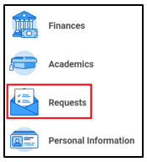

1. Choose **‘Create Request’** and click on **‘All’**. Choose **‘STUDENT PROGRAM OF STUDY: POS: Update Request’**and click **‘OK’**.

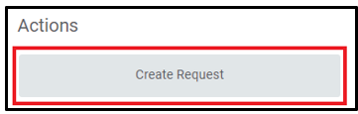

            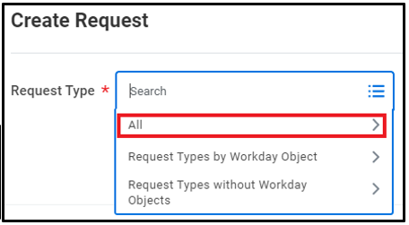

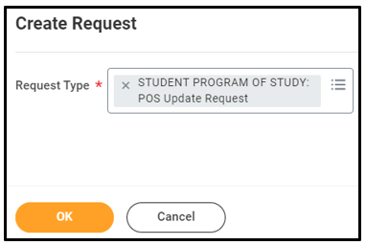

1. Before submitting your request, make certain your new major is located on your home campus by clicking on the links provided.
2. Review and answer the Financial Aid question.
3. Review all sections to make sure you complete the correct section.

* **Section A:** If you are wanting to change your current program of study, enter your new program of study here.
* **Section B:** If you are wanting to add an additional program to your current program of study, enter your additional program here.
* **Section C:** If you are wanting to remove a program from your degree plan, enter the program you are wanting to remove.
* **“Pre” Program:**If you are wanting to declare a “Pre” Program, choose from the list provided.
* **Section D:** If you are wanting to update the catalog year on your current program of study, enter the new catalog year here.

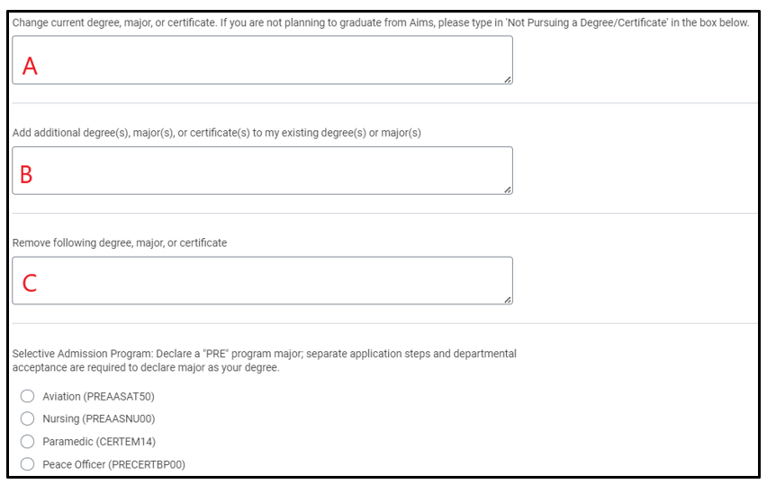

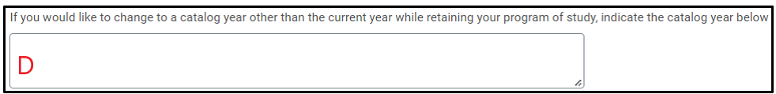

1. Select the semester you are wanting the program of study change to be effective for.
2. Review the links by campus for programs above (Step 3) to confirm the new program of study you are requesting is located on a campus near you, then select the appropriate campus as your home campus.
3. Press **‘Submit’**.
4. Once you have submitted your request, it will be directed to the Registration & Records office for processing.