Aims

Community College

Fire Academy

Information Packet

***(Fall 2025)***

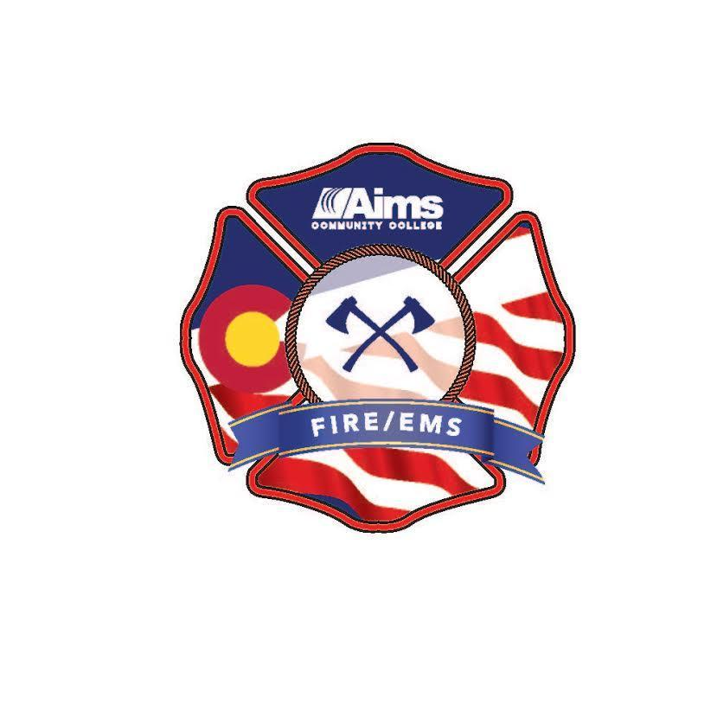

**Table of Contents**

Table of contents 2

Welcome 3

How to get started 4

Important information 4-6

CPR Information 7

Fire Academy Checklist 8

Contacts 9

**Welcome**

Thank you for considering the Aims Community College Fire Academy. The Fire Academy is a 13 credit program run over one semester. The Fire Academy consists of **THREE Courses**

**FST 1000 – Firefighter I (9 credits)**

**FST 1070 – Fire Clinical (Live fire, 1 credit))**

**FST 1007 – Hazardous Materials Operations (3 credits)**

The Fire Academy is offered in a day and night format during the fall semester (Mid-August thru Mid-December) and spring semester (Mid-January thru First part of May).

|  |  |
| --- | --- |
|  |  |
| **Meeting Times** | Day Fire Academy   * 2 days a week (Monday/Wednesday) * 8:00 AM to 4:00 PM * 2-3 Alternative Days for State Testing * Includes Hazmat (3 Monday afternoons in person)   Night Fire Academy   * 2 nights a week (Tuesday Thursday) and every other Saturday * 3 Monday nights are for FST 1007, Hazmat OPS (Hybrid) * Weeknights run from 5:30-10 pm (9:30 end for Hazmat) * Saturdays run from 8 am to 5:00 pm * 2-3 Alternative Days/Nights for State Testing |
| **Location** | **Windsor Campus – 1130 South Gate Drive Windsor, CO 80550**  *One off-campus live fire training event at Greeley FD Training Facility |
| **Credits:**  **FST 1000 = 9 credits**  **FST 1007 = 3 credits**  **FST 1070 = 1 credits** | 13 credits total for Academy -  Cost Sheet – Page 6 |
| ***CPR offered at Aims***  ***Fire Academy Pre-enrollment Fitness Assessment IS NOT a CPAT test and will not give you a CPAT certificate*** | **Current Healthcare Provider or Professional Level CPR Card**    **Demonstration of successful completion of the Fire Academy Pre-enrollment Fitness Assessment OR an official CPAT card that was issued within 12 months of the first day of class.** |

The Fire Academy is taught by a diverse group of Firefighters from the northern Colorado area making the Aims Fire Academy one of the most respected College Fire Academies in the State. The fire academy includes live fire training and meets all the requirements for students to take the Colorado Division of Fire Prevention State Firefighter I and Hazardous Materials Operations written and practical exams. Registration for the fire academy is on a first come – first served basis until the academy is filled.

**Getting started**

1. Apply to become a student with Aims at aims.edu/apply if you have not done so
2. Follow this link to find [Fire Academy Registration and Information](https://www.aims.edu/degrees-certificates/fire-academy)
3. You will be invited to a Group Advising Session with our Windsor Campus Pathway Advisors. **The advising session is mandatory, and you will receive the invitation from the advising office once you are cleared by our department.** The Group Advising Sessions are held via Zoom.

**Registration & Important Information**

1. **Registration for the academy will be on a first come – first served basis**. All students must be registered by the academy registration deadline, typically two weeks before class start date. All students must pay their bill in full by the payment deadline or sign up for the E-Cashier plan or they will be dropped from classes.
2. Sign up for a Pre-Academy fitness assessment by going to the CPAT website <https://www.aims.edu/degrees-and-certificates/fire-academy/cpat> **Scroll to the bottom of the page until you see the upcoming dates and click on the “Register now” button. You will be redirected to the page to sign up. Scroll to the bottom to find the dates for the fitness assessments and click on the one you wish to sign up for. Signing up for the ones that are upcoming first will give you a better chance of getting registered as soon as registration opens to secure your seat in the academy you prefer.**
3. Once you have all steps completed and we have sent the e-mail to you to register you will be instructed to contact Ronnie to get sized for your gear [Ronnie.riedel@aims.edu](mailto:Ronnie.riedel@aims.edu)
4. **Students must provide a copy of a current American Heart Association Healthcare Provider CPR card that remains current throughout the duration of the fire academy and state testing.** For information on CPR classes or to register for a class (See page 8 for details)
5. **Students need to plan on staying later than the scheduled times on several occasions to assist with cleanup and work detail. Also, please plan to bring your lunch when the academy is scheduled for a full day.**
6. Fire Academy students will need to purchase books and uniforms from the Aims bookstore prior to the first day of class (see list on page 5). **Please do not show up** **to the academy without the required items!**
7. Participation is required in performing skills that involve strenuous physical activity in order to successfully complete the academy. **All applicants enrolling in the fire academy are highly encouraged to start a physical fitness routine involving aerobic and anaerobic exercises in preparation for the academy.** Reference the CPAT Test Preparation Guide posted on the Aims Fire Academy website for details on how to prepare.
8. Students requesting accommodations must contact Disability Access Services before the first day of class. For further information call 970-339-6388 or email at disability@aims.edu.
9. Attendance is required for all class sessions of the Academy unless extenuating circumstances arise and/or prior approval is arranged through the Academy Coordinator and Lead Instructor. **Please do not be late for the first day of class.**
10. **Current NFPA requirements do not allow for a beard or facial hair at any point where the face-piece of a Self-Contained Breathing Apparatus (SCBA) is designed to seal with the face. Individuals will be required to shave any facial hair that interferes with the seal prior to the start of the academy.**
11. Academy Student Uniform & Book Requirements

**The following items must be purchased at the Aims Bookstore: (order as soon as possible!)**

* + ***Uniform shirt: (1)*** Short sleeve navy blue Class B uniform shirt with the Aims EMS/Fire Academy patch sewn on the left sleeve to a common dimension. NFPA 1975 compliant – 100% cotton.
  + ***T-shirts: (3)*** Academy T-shirts with the Aims logo are required for the physical fitness portions of the academy and may also be worn under the structural firefighting gear.
  + ***Pants: (2)*** Matching navy blue EMT pants
  + ***Athletic Wear:*** Fire Academy athletic shorts and sweatpants (sweatpants are optional to purchase, plain gray ash or navy color sweats are an acceptable substitute).

**The following items can be purchased at any store (Recommend Kinsco, Longmont Colorado)**

* + ***Boots:*** Black in color with black sole. Boots are to be at least a 4” quarter boot in the heel/ankle portion. Steel toe is recommended but not required. **Absolutely no tennis shoes or low-cut dress shoes**.
  + ***Belt:*** Black in color, Velcro or belt buckle type acceptable but buckle must be plain silver
  + ***Books:*** **(Recommend the Aims Bookstore)** **IFSTA, *Essentials of Firefighting* (7th edition)** text and workbook & **First Responder Hazmat book (6th edition)** Consult with the bookstore about current editions before making a purchase-Do not recommend rental

1. The academy has high academic standards. Students not meeting the standards set forth in the syllabus will be withdrawn from the class. In order to be successful in the Fire Academy, the average student will need to spend ***24 - 36 hours minimum outside of the scheduled classroom*** hours each week practicing skills, reading the textbook, participating in study groups, etc. In order to pass the class students must have an 80% or better, anything less will result in an “F” on the transcript.
2. Refunds will not be issued to students that withdraw from the academy for failing to meet the academic requirements if the withdrawal is after the drop date (15% of the total class time).
3. The Fire Academy is structured under a paramilitary format. Students will be expected to stand at attention at the beginning of class, address instructors and fellow students by rank or title, and will be required to complete additional assignments if academy rules are not followed. Additional assignments may include activities such as extra physical fitness workouts, written reports, or research papers.
4. Students will be required to take tests, quizzes, and complete and submit assignments in an online format. While a home computer and internet access is desirable, students can meet this requirement by coming to one of the computer labs on campus.
5. **Students will be expected to check their Aims email for important announcements and updates once they are registered**.

**Tuition/Fees**

*In-District classification for tuition purposes is for students who have been Colorado residents for a minimum of one year and who live in the Aims tax district.

**Out-of-District classification for tuition purposes is for students who have been Colorado residents for a minimum of one year and who live outside the Aims tax district.

***WUE – Western Undergraduate Exchange – Individuals living in certain western states may qualify for WUE tuition rates. Contact the registrar’s office for details (970-339-6404).

****Out-of-State classification for tuition purposes is for students who have not been Colorado residents for a minimum of one year.

**Fire Academy**

**Approximate Costs**

|  |  |  |  |  |
| --- | --- | --- | --- | --- |
| **Item** | **In-District Cost\*** | **Out-of-District Cost\*\*** | **WUE\*\*\*** | **Out-of-State Cost\*\*\*\*** |
| **Total Tuition & Fees** | **$4015** | **$5,198** | **$6,598** | **$10,333** |
| Bookstore Items  (Approximate Costs) |  |  |  |  |
| Leather work gloves (1pr.) | $15.00 | $15.00 | $15.00 | $15.00 |
| Athletic shorts & sweatpants (1 ea.) | $80 | $80 | $80 | $80 |
| Academy T-shirt  Drill Ground (2) | $12.00ea | $12.00ea | $12.00ea | $12.00ea |
| Academy Class B  Station Shirt (1) | $65 | $65 | $65 | $65 |
| Academy Uniform Pants | $43 | $43 | $43 | $43 |
| Textbook & workbook for the fire academy | $170  New | $170  New | $170  New | $170  New |
| HazMat book | $92  New | $92  New | $92  New | $92  New |
|  |  |  |  |  |
| Approximate Totals | $5,312 | $6,495 | $7,895 | $11,600 |
|  |  |  |  |  |
| Prerequisite Costs |  |  |  |  |
| Official CPAT Test **(If desired, not required)**  Pre-enrollment fitness assessment  CPR | $115  $0  $85 | $115  $0  $85 | $115  $0  $85 | $115  $0  $85 |

American Heart Association CPR

How do I sign up?

BLS for Healthcare Providers – **This class is for healthcare providers such as CNA, MA, EMS personnel, physician assistants, doctors, dentists, nurses, phlebotomists, rad tech, and respiratory therapists. This course covers choking, one-rescuer and two-rescuer CPR for an Adult, Child, and Infant. It also covers the use of an AED, pocket mask, and bag valve mask. American Heart Association Certification is valid for a 2 year period.**

Go to the following website: [CPR Registration link](https://aimsced.augusoft.net/index.cfm?method=ClassListing.ClassListingDisplay&int_category_id=19&int_sub_category_id=247&int_catalog_id=)

1. View the class options and pick a date that works for you. Each class is a 4-hour class.
2. When you have decided which class works best for your schedule, click on “**Add to Cart**.”
3. This will prompt an option to create a new user profile (unless you are a returning student to the non-credit sign in page). “My Aims” usernames and passwords and “A” numbers WILL NOT work as a valid sign in. Create a new username and password. Please read the Refund Policy!
4. Enter your credit/debit information onto the secure server. After payment has been processed options are provided for printing payment receipts and registration confirmation if necessary. The registration confirmation will have the course date, time, and location for reference.

You **WILL NOT** be allowed to have a seat in class if you are not on the official roster for the class. You must complete the registration process and have payment received by Aims to be officially registered for the class. Completion cards will be issued after successful completion of the class.

**Fire Academy Checklist**

* Apply to become a student with Aims at aims.edu/apply if you have not done so already..
* **Read the Information packet located on the website and follow the instructions in that as well as what is located on the fire academy website. You may contact** [**fire.science@aims.edu**](mailto:fire.science@aims.edu) **with any questions you have about anything regarding fire academy registration but PLEASE read this packet in it’s entirety, most questions are answered within this packet**
* **RSVP for and attend a Group Advising Session when you receive an invitation from Pathway Advising.** (Note: Do NOT call the advising department to schedule an appointment; you will be issued an invitation to a session when you are cleared for advising from the Fire Science Department.)
* **Attend and pass the Academy fitness assessment – If you have a CPAT certification just provide a copy to the program at** [**fire.science@aims.edu**](mailto:fire.science@aims.edu) **You DO NOT need to do the Academy fitness assessment if you have a valid CPAT certificate**
* **Register for the Academy before this deadline** (August 8th, 2025) Registration directions will be provided after the Group Advising session.

**CPR Certification (HEALTHCARE PROVIDER) before the first day of class**. Bring a copy of the certification to the first day of class.

* **Setup appointment with** [**Ronnie.riedel@aims.edu**](mailto:Ronnie.riedel@aims.edu) **to get measured for structural PPE (ONCE YOU ARE FULLY REGISTERED)**
* **Purchase uniforms (Sooner the better)** indicated on the attached list before the first day of class. The uniforms are available at the Aims Bookstore – Call 970-339-6576 or 970-339-6457 for information on when the equipment will be available to purchase.
* Appropriate dress for the first day of class includes:

Academy uniform navy-blue station button up shirt (class A)

Academy uniform navy-blue pants

Black boots-no scuffs

Clean shaved (males)

**Contacts**

**General fire academy information**

[**fire.science@aims.edu**](mailto:fire.science@aims.edu)

**Fire Science Program Director**

John McDougall

Public Safety Institute, Room 153 – Windsor Campus

Phone – 970-339-6694

Email – [john.mcdougall@aims.edu](mailto:john.mcdougall@aims.edu)

**Fire Academy Program Manager**

Ronnie Riedel

Public Safety Institute, Room 157

Phone- 970-378-3575

Email- [Ronnie.riedel@aims.edu](mailto:Ronnie.riedel@aims.edu)

**Windsor Campus Advisors**

Public Safety Institute Building, Room 140 – Windsor Campus

Phone – 970-339-6610, Option 2